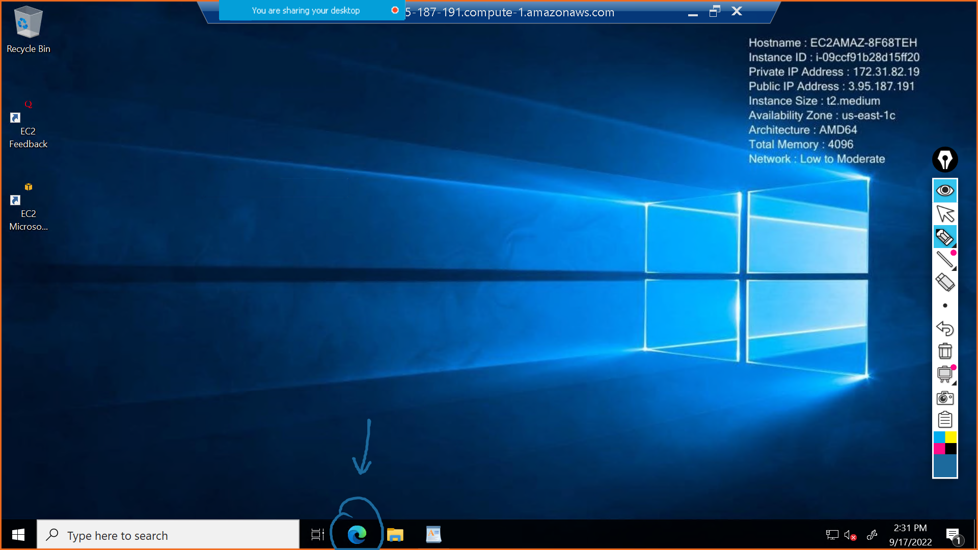

open <https://gitforwindows.org/>

download git for windows

Keep every setting as default and install git

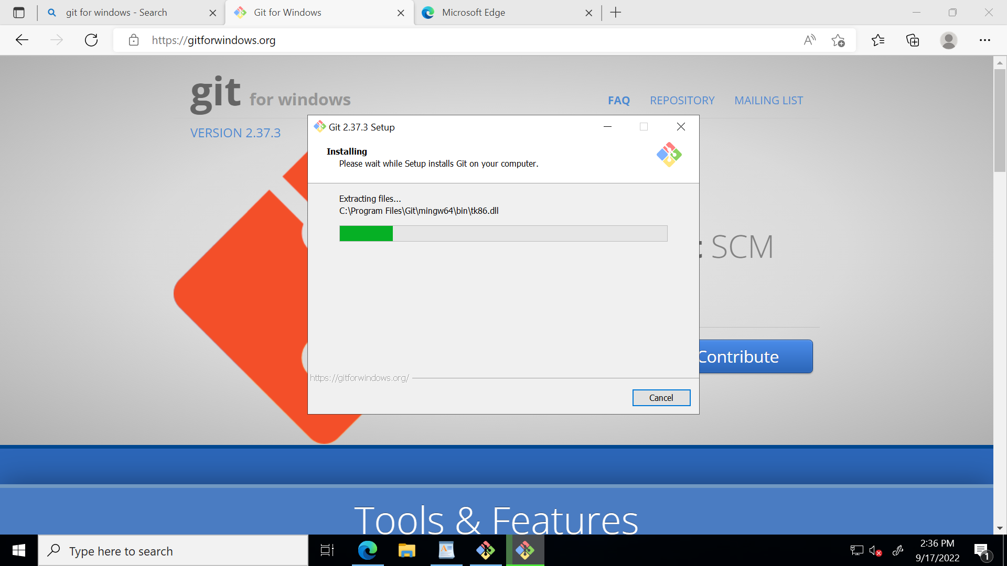

#to check if git is installed properly or not

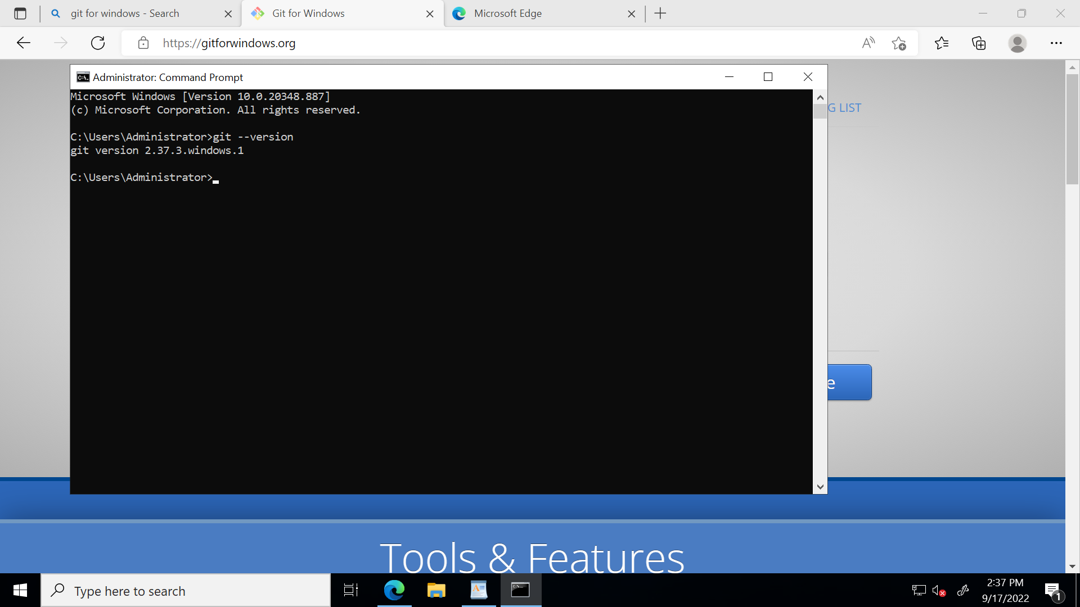

<https://www.oracle.com/java/technologies/javase/jdk11-archive-downloads.html>

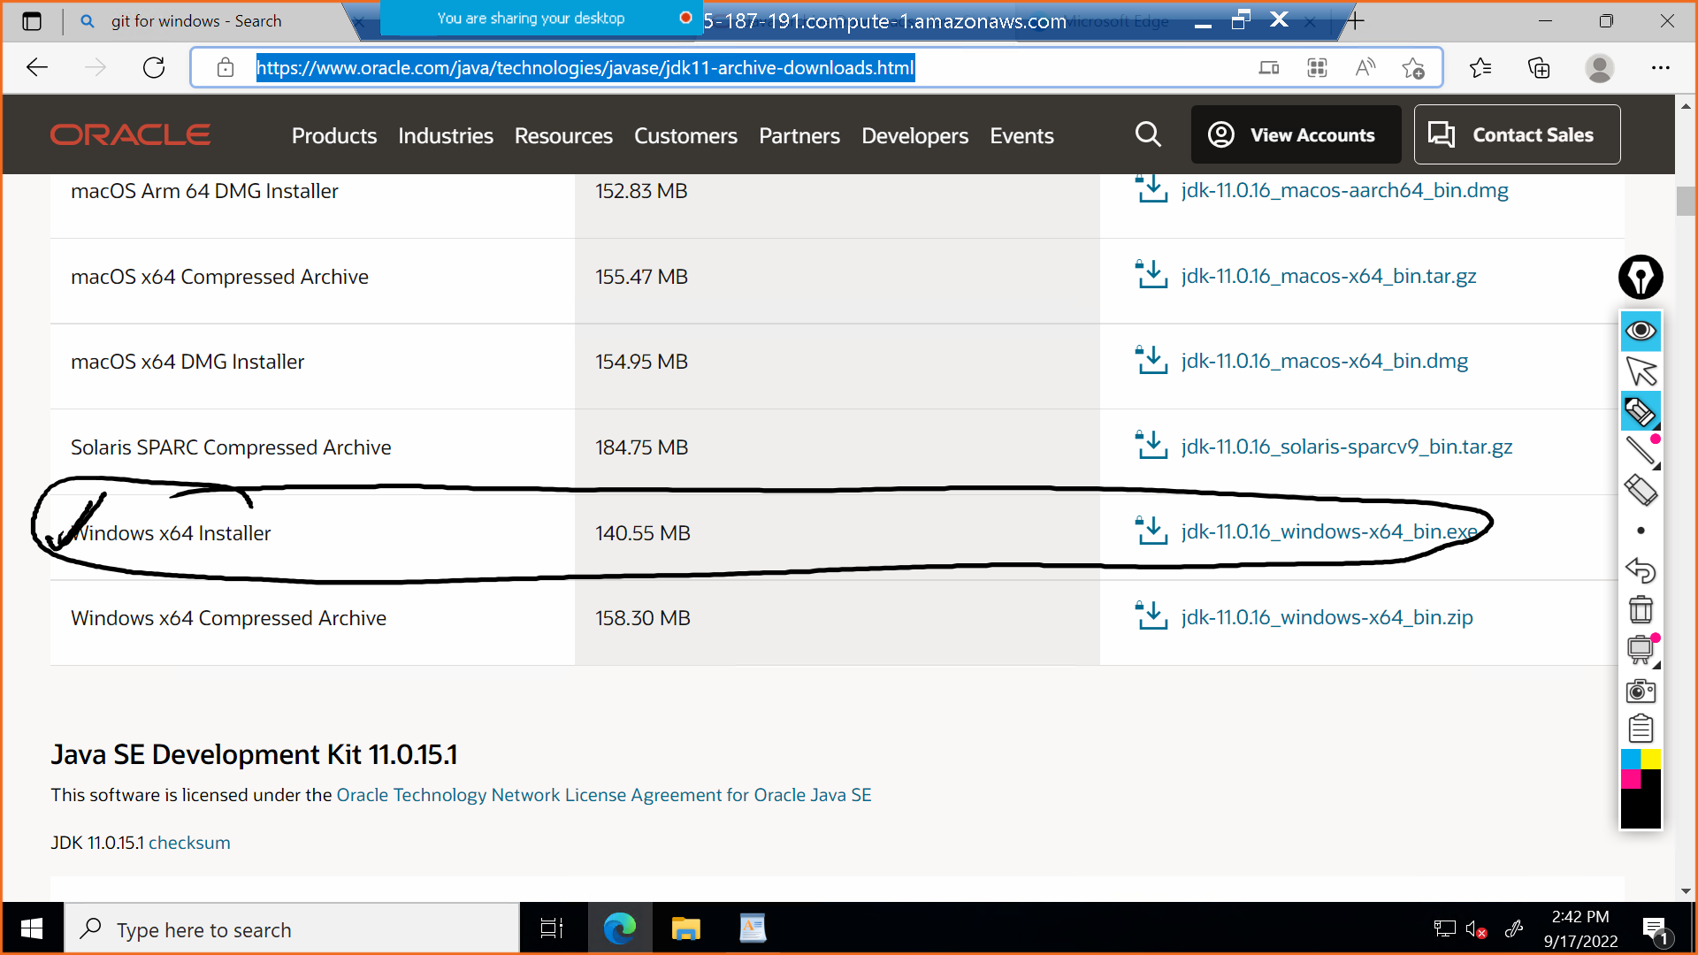

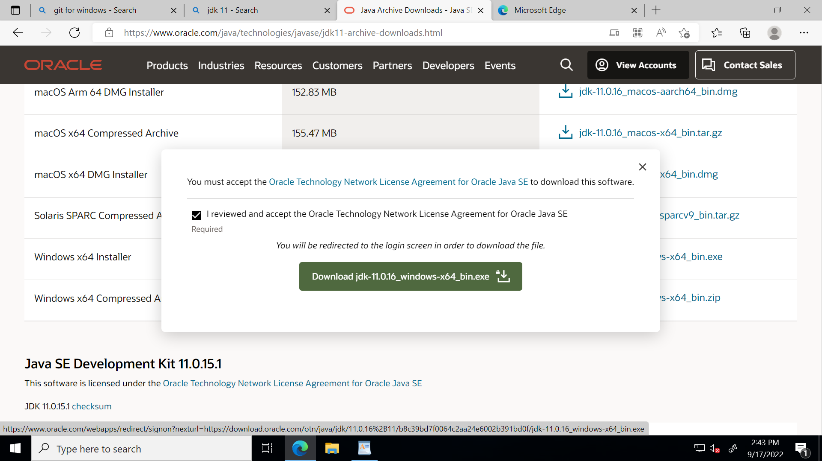

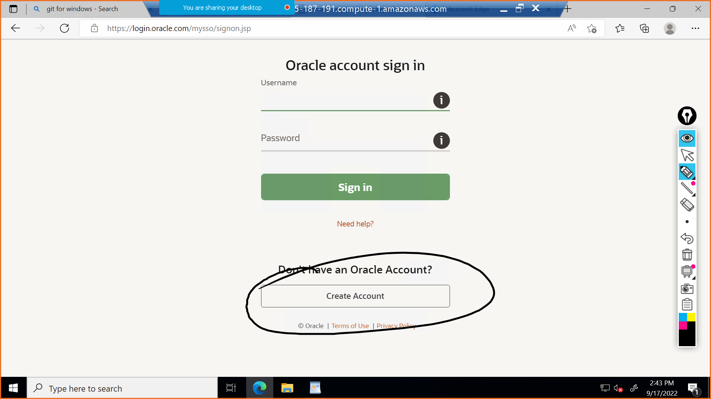

After creating the account ...signin.....after u signin you will see that jdk11 will start downloading

install java ...keep everysetting as default

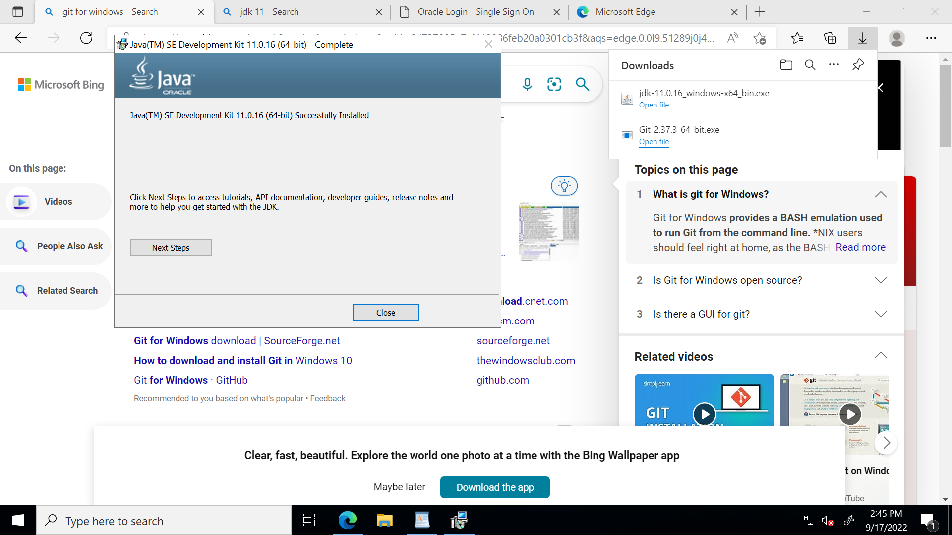

now go to c drive of machine -> program files -> java -> u will see jdk 11 folder

C:\Program Files\Java\jdk-11.0.16

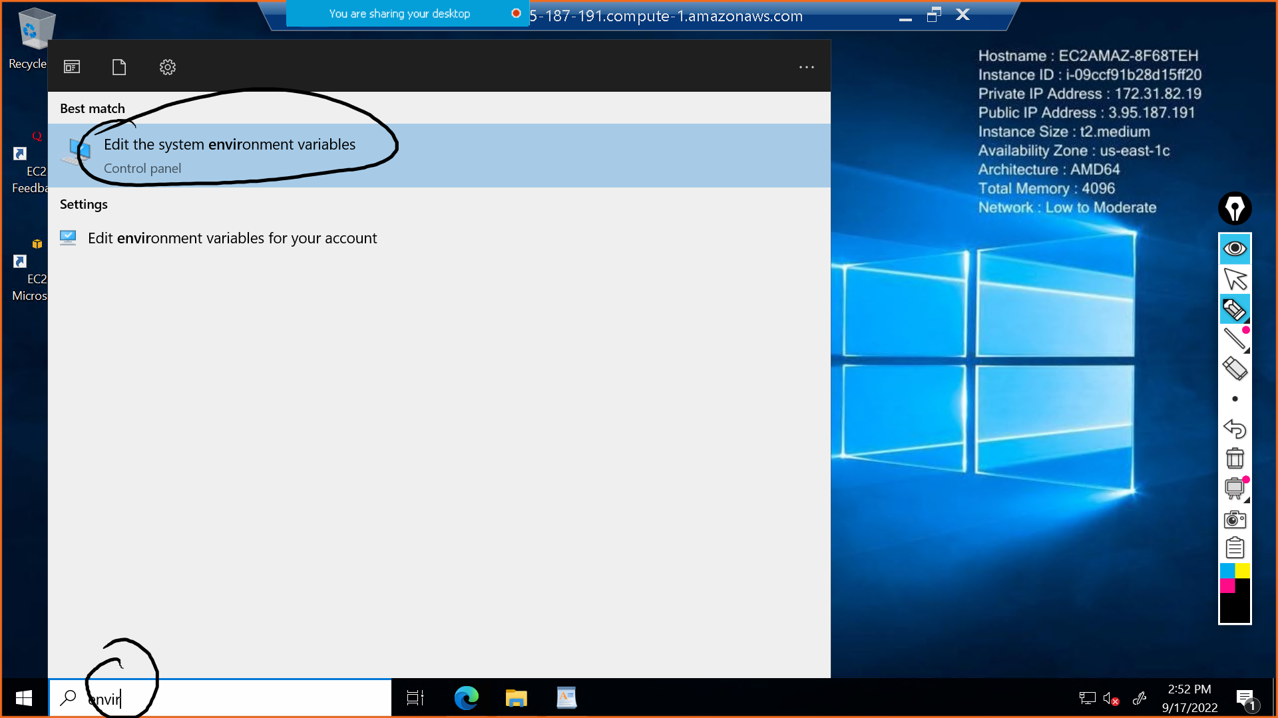

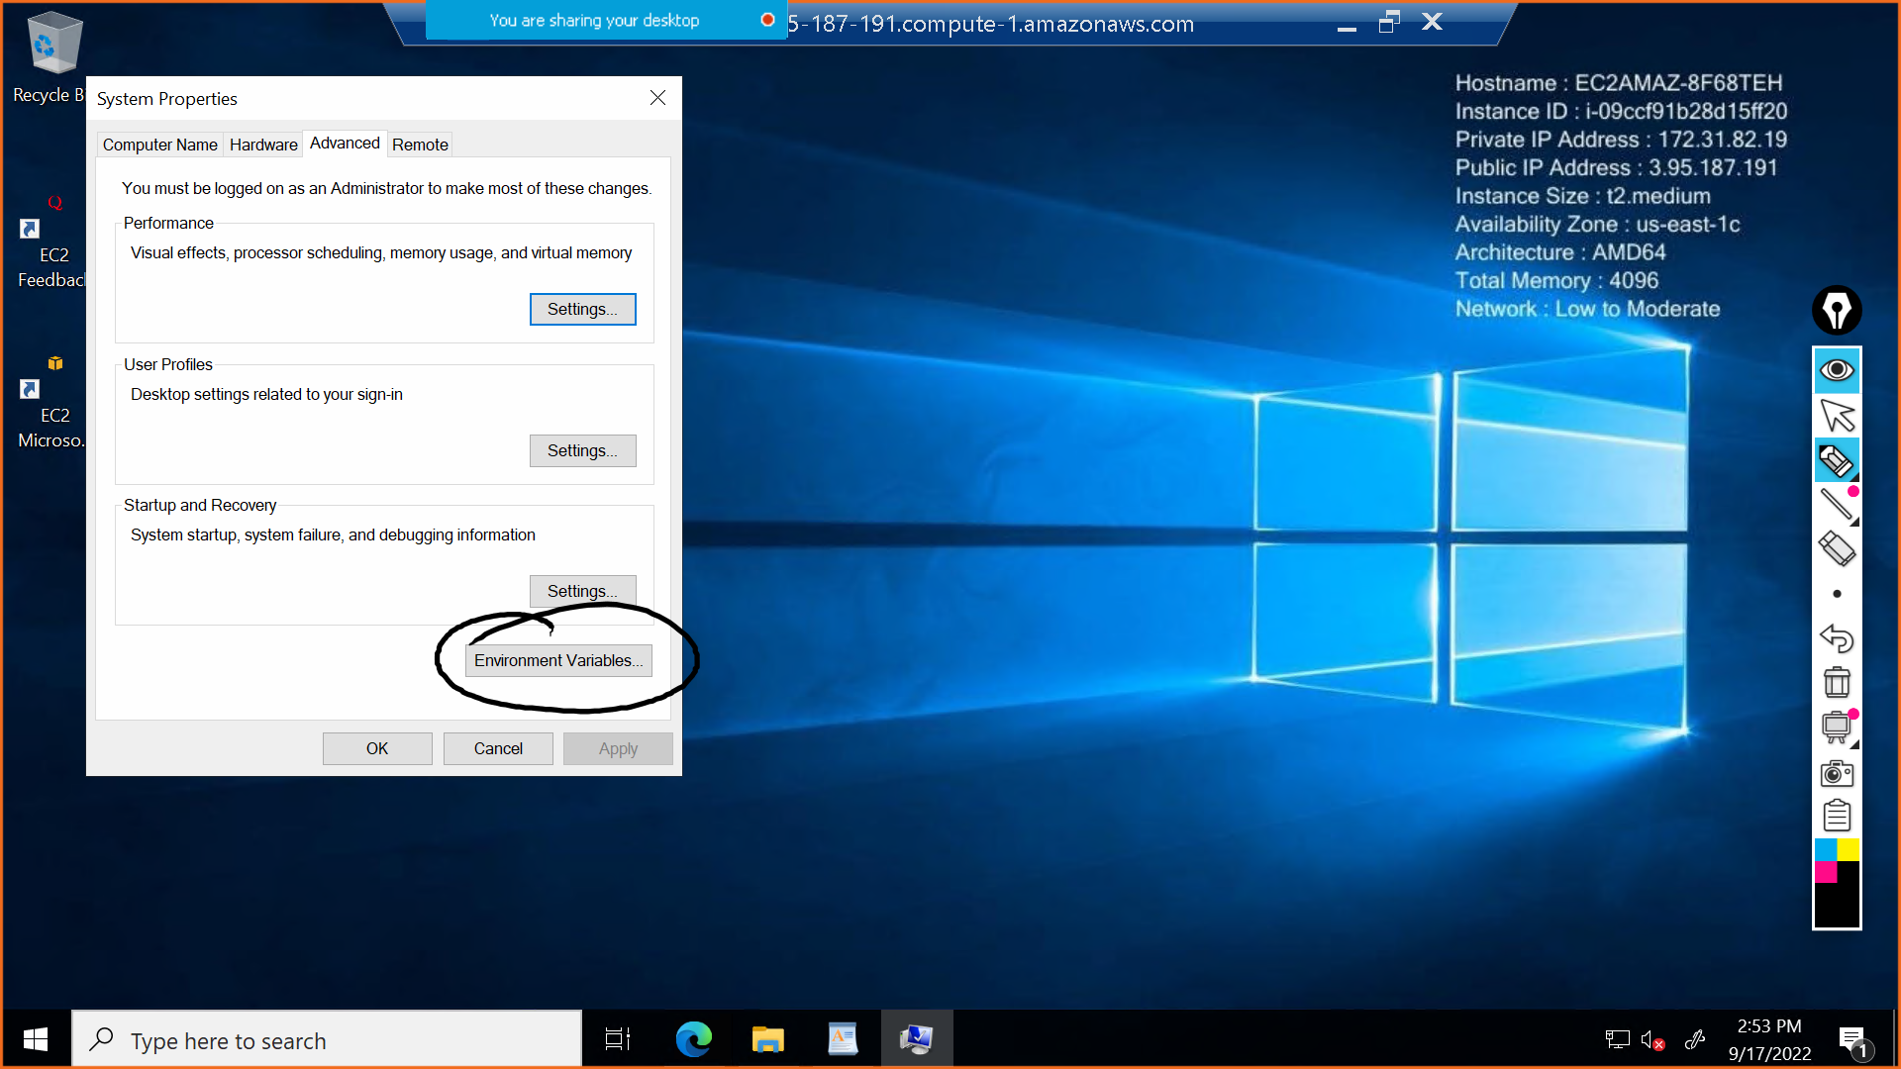



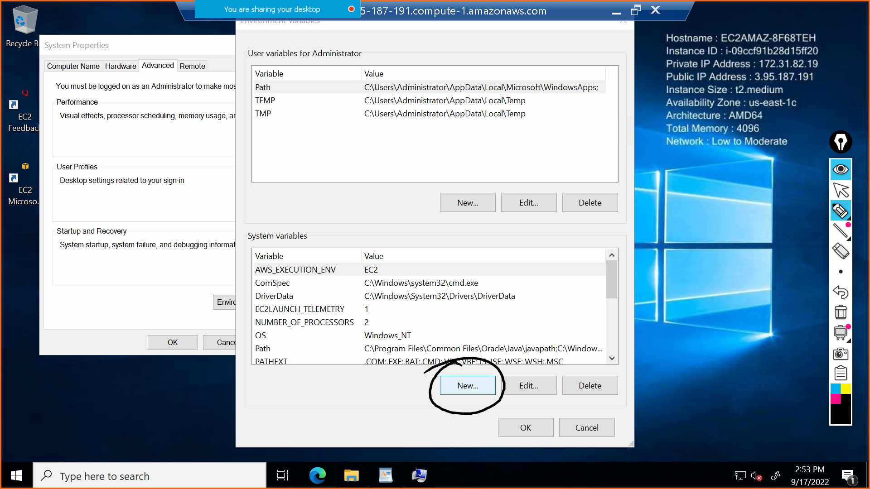

Variable name :JAVA_HOME

path : C:\Program Files\Java\jdk-11.0.16

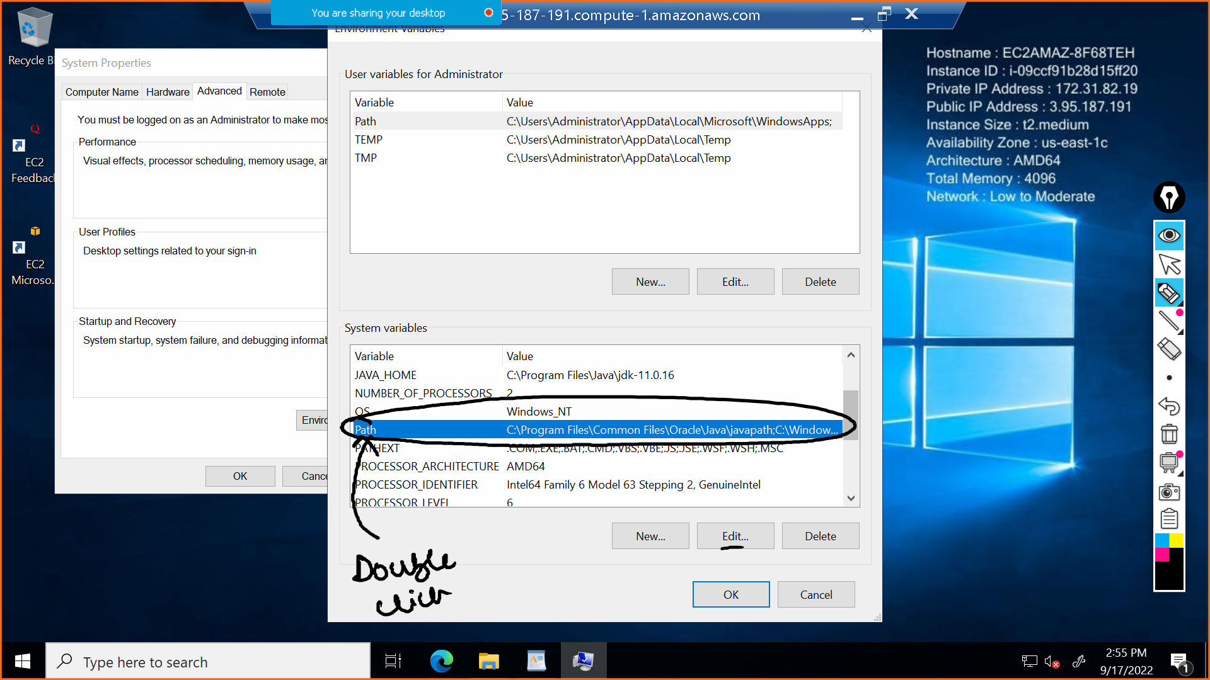

C:\Program Files\Java\jdk-11.0.16\bin

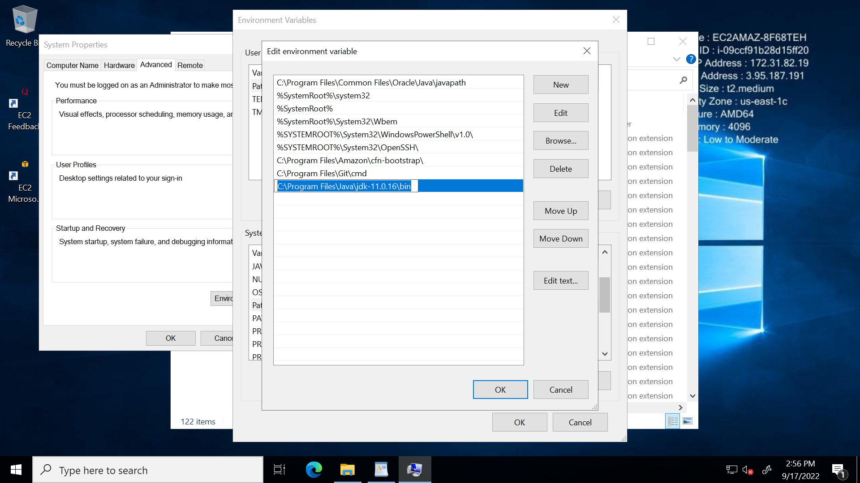

ok ok ok ok ok

**Lets check if java is installed properly or not**

open cmd (just search it in startup search bar)

echo %JAVA_HOME%

if output is coming as path of java jdk11 it means ur environment variable is set properly